**(Logo Slide #1 The General Foundations of Our Faith Series)**

**Introduction** =

**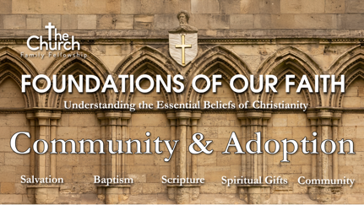***(Today we will be concluding the 6th and final sermon in our topical series entitled* **(Logo Series Slide #2 Foundations of Our Faith - The Church Community & Adoption Process)** *Yes, this sermon answers the question, “how do I become a part of The Church Family Fellowship”. In fact, each sermon in this series has been all built upon each other one, and each one has been shared with you by one of The Elders of The Church. All six (6) of these sermons were provided to explain who we are as a Church, what we believe, and how you can become a part of this local Body of Christ here at The Church Family Fellowship.*

*By now my hope is that you have become very familiar with* ***our church’s vision statement****, which has more of* ***a global perspective****…*

**(Slide #3 The Vision Statement)**

*“Our desire and design is* ***to see all***

***believers maturing*** *and*

***serving effectively***

*in* ***unity***

*so* ***all people***

***embrace God*** *in an*

***intimate relationship,***

***giving Him all the glory****.”*

*Additionally, you have heard* ***our church’s mission statement****, which is a little bit* ***more of a local perspective****, in that it is more specific to this church, “The Church Family Fellowship…”*

**(Slide #4 The Mission Statement)**

*“The Church exists by God’s grace*

*as*

*a community of believers*

*equipping Christ-Followers to*

*exercise the grace gifts given them*

*for*

***glorifying God,***

***growing up the body,*** *and*

***going out to reach the world.****”*

*In reference to our Mission Statement, I want to draw your attention to two phrases.* **(Slide #5)** *First, “****a community of believers****” and then the phrase “****the body****”. Now what do we mean when we reference these phrases?*

**(Slide #6)** *“****The Body****” refers to “****The World-wide Body of Christ****” – all believers wherever they may be located.*

**(Slide #7)** *Whereas the phrase, “****A Community of Believers****”, refers to the* ***local church****.*

*The local church is a group of believers who gather together as one community, in one specific location, to become equipped and exercise their spiritual gifting all for the glory of God, and for the growing up of the body, so we can then more effectively go out into the world to be light and salt within it.*

*Now, as “****a community of believers****”, God’s word has laid out some very clear instructions for the* ***organization (which is our process)*** *The Church and given us all a* ***commission (which is our purpose)*** *to follow. Therefore, God has provided us The Church with instructions for its organizational structure in much the same way He has provided us with instructions for the structure and organization of the family.*

*For example,* ***here is my family****…* **(Slide #8)**

*Now a family is made up of many members and not all of them come into the family the same way, nor do they serve the same function, nor operate in the same way.*

*There are those who* ***head up or lead*** *the family…* **(Slide #9)**

*There are those who are* ***natural biologically born members*** *of that family…*

**(Slide #10)**

*And there are* ***some who become legal members*** *of that family* ***through adoption****…*

**(Slide #11)**

*And some become* ***members legally through marriage****…* **(Slide #12)**

*And when all is said and done* ***the natural and healthy outgrowth of that family is to produce more members*** *being born into that family through both new birth and their commitment through legal means…* **(Slide #13)**

**And that is how The Church – Oops, I meant the family – grows. Additionally, you will also have those who come alongside us* ***as friends****.* **(Slide #14)** *They often come along to check things out, perhaps they too will one day choose to become potential future family members. This is what we at The Church Family Fellowship refer to as* ***Adopted Members of The Church Family****…* **(Slide #15)**

*Which is what leads me into my topic for today’s sermon…*

**(Logo Slide #16 Foundations of Our Faith - The Church Community & Adoption Process)**

*In preparation for this sermon, I came across a great article from 03/16/2017 on the topic of…*

# Church Membership and Prescriptive Implication

*by a Pastor by the name of Sean DeMars, who pastor’s at the 6th Avenue Church in Decator, Alabama, and he stated…* **(Slide #17)**

“It might surprise you to find out that I don’t believe that the New Testament anywhere teaches church membership **explicitly**. To be sure, **Matthew 18:20 is explicit**, but the line drawn from a few Christians gathered in Jesus’ name to names on a membership role is a squiggly one, requiring a certain measure of **implicit reasoning**. The modern requirements for explicit proof-texts are tremendous. So tremendous, in fact, that many Christians are unwilling to accept Bible-based arguments for church membership unless one can produce a proof text that uses the word “list” or “rolls.” Jonathan Leeman’s response to such stringent textual demands seems appropriate: “When people ask me, ‘Is church membership even in the Bible?’ I’m half tempted to reply, ‘No, it’s not in the Bible, at least not in the way that you mean.’”

*So, when it comes to discussing Church Membership, several of you may come at it from a perspective of* **(Slide #18)*****“CHURCH MEMBERSHIP!! That’s secular and evil! That’s not taught in the Bible!!!”*** *But the truth is that whereas some of things that we teach in Bible Believing and teaching churches are explicitly stated in scripture, there are others that we teach that are more clearly implied, or implicit within the body of the scriptural text.*

**(Slide #19)***Let’s talk about the* ***difference between Explicit and Implicit****.*

*Let me give you a few examples of what I mean by implicit within the context of God’s word.*

**(Slide #20)**

*First is “****the Trinity****” – the word “Trinity” is not stated in the scriptures anywhere and yet there are an abundance of scriptural references throughout the word of God that, when put together, clearly teach that God the Father, God the Son, and God the Holy Spirit are three in one* *(Matthew 28:19, John 14:9-11, 1 Corinthians 12:4-6, 2 Corinthians 1:21-22, Philippians 2:5-8, Colossians 1:15-17, Ephesians 4:4-6, 1 Peter 1:2) The Trinity is a doctrine that we hold to and teach that is implicit within the Bible.*

**(Slide #21)**

*Next is* *“****the Rapture of the Church****” – the word “Rapture” is not stated directly in the original Greek language, but the translation of 1 Thessalonians 4:17 in the Greek which uses the word “harpazo” meaning “to snatch or take away” into Latin provided up with the word “rapturo” which refer to us being “taken up”, with this in combination with other texts within scripture we can clearly implicitly conclude that the dead in Christ will rise first and then we who are still alive with be “caught up” (raptura-ed) and meet them in the air**.”(Matthew 24:30-31, Mark 13:24-27, Luke 17:34-37, John 14:3, 1 Corinthians 15:51-53, Philippians 3:20-21, 1 Thessalonians 4:16-18) The doctrine of the Rapture is taught implicitly within the scriptures as well.*

**(Slide #22)**

*Why even the word “****Bible****” isn’t in the Bible. – the reason is because the word “Bible” is from the Greek word for “the books”. “Bible” is a descriptive name of what the thing is - a collection of several books compiled together into one larger book. There’s no reason the word would appear in the book because the original writers were totally unaware that their writings would be collected and edited into one volume.*

*I’d like you to hear from a few of the current biblical teachers of our day and what their comments are on Church Membership…*

**(Slide #23)**

**Alistair Begg** speaking on **Church Membership out of Romans 12** in his sermon entitled **Membership Matters**, makes the following statements about the body of Christ being in membership with one another…

“Now these New Testament pictures not only imply close relationships, but they imply order, and they imply structure…”

He goes on to say, “I cannot find a way to conclude that God has ordained the church to be some kind of unstructured and loosely knit association that functions spontaneously.”

He then concludes his introductory comments on this topic of membership and speaking about the body of Christ and the family of God by saying, “In order for any group any family to function people have to know who is in the family.”

# Essential Beliefs

# By Chuck Swindoll

## The Family of God

We are grateful to be a part of the local church, which exists to proclaim God’s truth, to administer the ordinances, to stimulate growth toward maturity, and to bring glory to God.

Believers are called to faithful membership in a visible, local congregation for the purpose of mutual encouragement and spiritual growth. As the family of God, a healthy local church is marked by God-glorifying worship, Scripture-centered teaching, intimate fellowship, and vivid expressions of the church’s faith, hope, and love through evangelism, disciple-making, financial support, and service. (See Acts 2:41–47; Philippians 2:1–4; and Hebrews 10:24–25.)

**(Slide #25)**

# A person in a suit Description automatically generated with low confidenceChurch Membership

# By John MacArthur

**A GRACE COMMUNITY CHURCH DISTINCTIVE**

In a day when commitment is a rare commodity, it should come as no surprise that church membership is such a low priority to so many believers. Sadly, it is not uncommon for Christians to move from church to church, never submitting themselves to the care of elders and never committing themselves to a group of fellow believers.

To neglect—or to refuse—to join a church as a formal member, however, reflects a misunderstanding of the believer’s responsibility to the body of Christ. And it also cuts one off from the many blessings and opportunities that flow from this commitment. It is essential for every Christian to understand what church membership is and why it matters.

**(Slide #26)**

**Is Church Membership Really**

**a Biblical Concept?**

**Sam Storms** Pastor, Author 2018 **6 Apr**

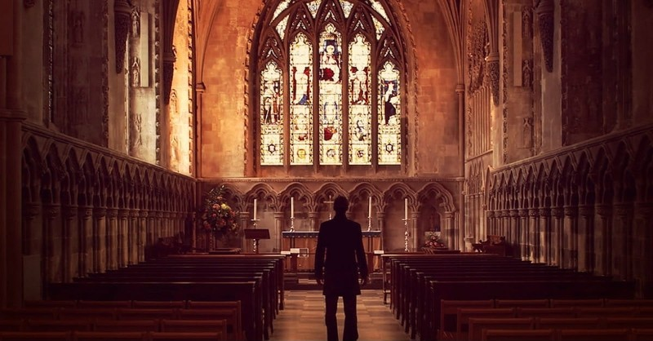

**Membership in a local church** is very much in the minds of Christians these days. Is it biblical? Is it necessary? Is it helpful? These and other questions lead to the following **ten things you should know about church membership** means and entails. **Perhaps the best place to begin is by asking the question: What do you want from your local church?**

I assume, first of all, that **you want a local church where you can be known and loved and cared for by other Christians**. There is, after all, no such thing as an “anonymous-lone-ranger-Christian” in the NT. You can certainly remain anonymous if you want to. It’s easier to do in a church of several thousand where you can slip in on a Sunday morning and sit along the wall and never engage anyone in fellowship or conversation or accountability. So, yes, you can do that if you want. But why would you want to?

I also assume **you want a local church where you can know others and experience the joy of pouring into their lives and loving and encouraging and helping them and ministering to their needs**. In other words, **you want a local church,** I assume, **where you can be useful and be a blessing to others who are struggling and need your input.**

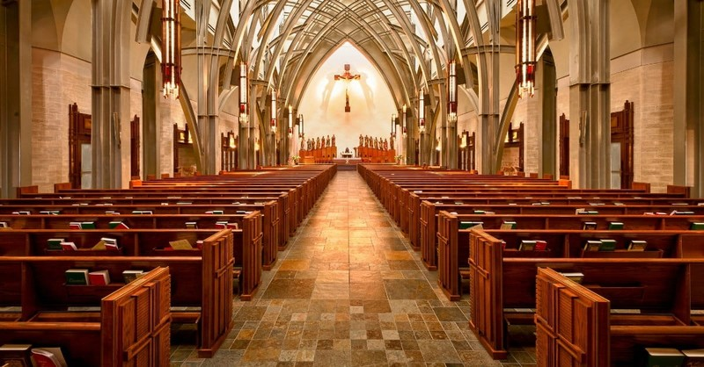Finally, I assume **you want a local church where you can be spiritually led and biblically fed and lovingly protected by gifted leaders.** I assume **you want leaders who not only know who you are but are joyfully committed to keeping watch over your souls, leaders who take seriously their responsibility to teach you the truth and help you grow in your knowledge of God and your intimacy with him.**

Photo Courtesy: Thinkstock

**(Slide #27)**

**1. Church membership is not a club, it is a covenant relationship**

Let’s begin by describing **what I do not mean when I speak of covenant membership** in the local church. Our aim is to avoid thinking of the local church in “religious” terms, such that **“membership” is (NOT) the card you carry** that entitles you **to show up when you please**, **consume only what you desire**, **and live however you wish** on any day other than Sunday. The concept of **“membership”** has too often been associated with (**is NOT about) power, privilege, and** an approach to the Christian life that grants a person all the **“perks” of being thought of as a “believer” but with few or no responsibilities**.

The last thing in the world that we envision when we think of covenant membership is the idea of a Christian congratulating himself/herself, and taking [pride](https://www.ibelieve.com/faith/the-sin-of-pride-and-why-its-so-deadly.html) in membership in such a way that others are left feeling judged or excluded or second-rate. **Covenant membership is not a badge that one flashes to make known their spiritual maturity.** Our desire, on the other hand, **(Instead it) is (means) to call Christian men and women to a more genuine, authentic, heartfelt**, and holistic **relationship with other Christians that entails commitment and discipleship** and provides us **with a more effective means to display the glory of Christ.**

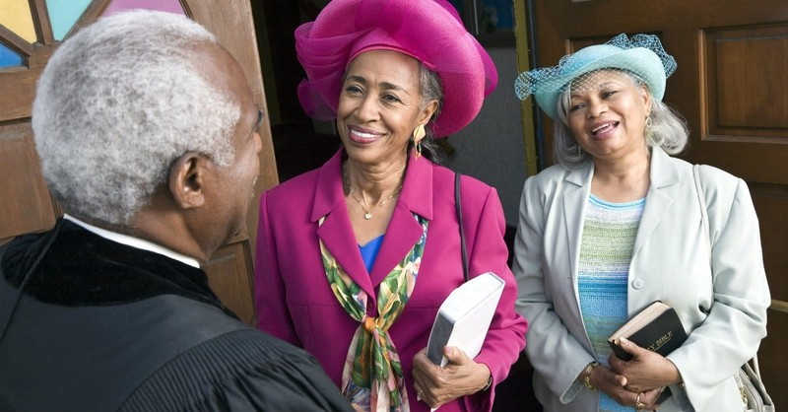The church is not a club we join in order to reap certain benefits at our leisure, whenever we please, but **(It) is rather a complex of relationships of mutual encouragement** and **spiritual accountability** in which we partner with one another **for the advance of the gospel in the earth.**

Photo Courtesy: Thinkstock

**(Slide #28)**

**2. "Covenant Membership" is intentional commitment to every other member**

What, then, do we mean by the words “covenant membership” when it comes to the local church? To be **a covenant member simply means that an individual is identified with, is accountable to, and is a contributing participant to this local expression of the body of Christ.** With covenant membership there are certain commitments that are made, responsibilities that are embraced, and relationships that are acknowledged.

Covenant membership in a local church, therefore, is**the way in which the individual is known to be intentionally committed to every other member of the congregation, and the congregation is known to be committed to the individual.** Covenant membership means, “**I now put myself under the care of the Elders** and **I invite them to hold me accountable as a** constituent **member of this body** (**and I commit to do the same for them**).”

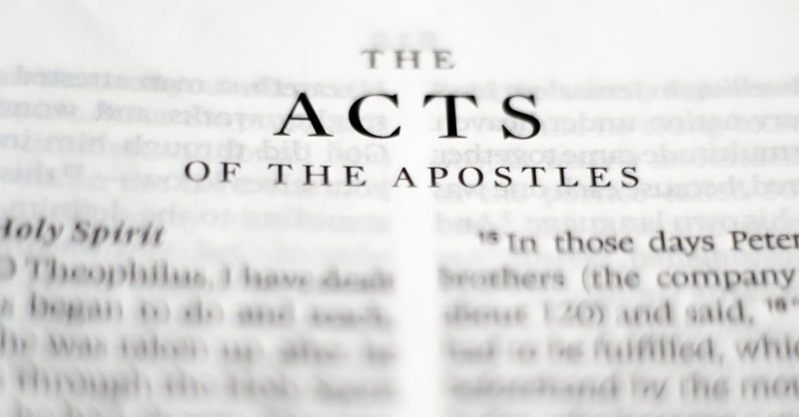Photo Courtesy: Thinkstock

**(Slide #29) *(Sermon video point at 50:28-50:46)***

**3. The Bible tells us that we are to bear one another’s burdens and thus fulfill the law of Christ, we can’t do so if we don’t know who one another are?**

Does the Bible explicitly mention a covenant membership in the New Testament or describe any formal church membership process? No, it does not. However, there are numerous truths and responsibilities in the NT which would be minimized or denied if there were no definable local church membership. The fact that membership is not explicitly mentioned does not mean it didn’t exist. **Those things which are explicitly mentioned *necessarily assume* that covenant membership existed.**

**For example, Galatians 6:1-2, we are told, “Brothers, if anyone is caught in any transgression, you who are spiritual should restore him in a spirit of gentleness. Keep watch on yourself, lest you too be tempted. 2Bear one another's burdens, and so fulfill the law of Christ.”** **However, if we do not know who “one another” are, then how can we fulfill the law of Christ? Or how then can we “bear one another’s burdens”?**

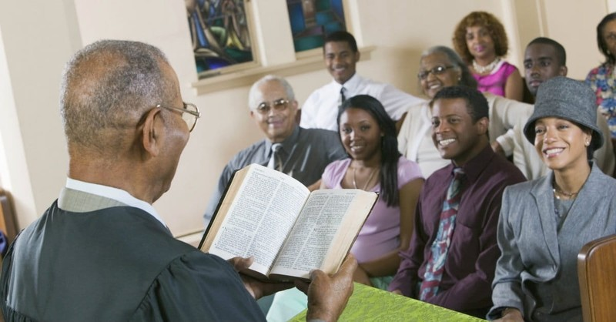We must conclude that some formalized membership must have been in place in order know who “one another” are. And if we conclude that covenant membership is necessarily entailed by the [Bible](https://www.biblestudytools.com/)’s commands for the church and the description of its life, we are morally obligated to pursue it in our churches today. If we conclude that it is not, we are free to regard local church membership as a matter of prudence which we may disregard if we think it not to be helpful in fulfilling our calling as the body of Christ.

Photo Courtesy: Lightstock

**(Slide #30)**

**4. The Bible requires Christians to be submitted to a group of church leaders (Thus, Church membership is *implied*.)**

**Church membership is implied in the biblical requirement of Christians to be submitted to a group of church leaders, Elders, or**[**Pastors**](https://www.crosswalk.com/church/pastors-or-leadership/)**.**

The point here is that without covenant membership, who is it that the NT is referring to who must submit to a specific group of leaders? And who are those leaders? No one would argue that a believer is required to submit to the authority of just anyone who chooses to designate himself an Elder or Pastor. **Some kind of expressed willingness or covenant or agreement or commitment (that is, membership) has to precede a person’s submission to a specified group of leaders who themselves are committed to providing spiritual direction to those who have acknowledged their authority.** In this regard, see [1 Thessalonians 5:12-13](https://biblia.com/bible/esv/1%20Thess%205.12-13); [1 Timothy 5:17](https://biblia.com/bible/esv/1%20Tim%205.17); [Hebrews 13:17](https://biblia.com/bible/esv/Heb%2013.17);

Photo Courtesy: Thinkstock

**(Slide #31)**

**5. Another way covenant membership is implied is through a charge to Elders**

Some basic concept of covenant membership is implied in the way the NT requires Elders to care for the flock in their charge. Of course Elders can extend their love to anyone and everyone, and should, within the limits of their ability. But the question is whether the Bible tells Elders that they are to have a special responsibility and care for a certain group, a group of members.

Consider [Acts 20:28](http://www.biblestudytools.com/search/?t=niv&q=ac+20:28) where Paul tells the Elders how to care for their flock: **“Pay careful attention to yourselves and to all the flock, in which the Holy Spirit has made you overseers, to care for the church of God, which he obtained with his own blood” (**[**Acts 20:28**](http://www.biblestudytools.com/search/?t=niv&q=ac+20:28)**).**

This verse does not say Elders cannot visit unbelievers or those who are not yet members. But it does make clear that their first responsibility is to a particular flock. How are they to know who their flock is? Who are the Elders and [Pastors](https://www.crosswalk.com/church/pastors-or-leadership/) responsible for? For whom will they give an account to God?

The way Peter speaks to the Elders in [1 Peter 5](http://www.biblestudytools.com/search/?t=niv&q=1pe+5) is even clearer on this point: **“Shepherd the flock of God that is among you, exercising oversight, not under compulsion, but willingly, as God would have you; not for shameful gain, but eagerly; not domineering over those in your charge, but being examples to the flock” (**[**1 Peter 5:2-3**](http://www.biblestudytools.com/search/?t=niv&q=1pe+5:2-3)**).**

“Those in your charge” (your portion, your lot) implies that the Elders knew those for whom they were responsible. This is just another way of talking about membership. If a person does not want to be held accountable by a group of Elders or be the special focus of the care of a group of Elders, they will resist the idea of membership. And they will resist God’s appointed way for them to live and be sustained in their [faith](https://www.crosswalk.com/faith/).

Photo Courtesy: Thinkstock

**(Slide #32)**

**6. Church membership is implied through the New Testament teaching of church discipline**

Church membership is necessarily implied by the teaching in the NT on church discipline. In [Matthew 18:15-17](https://biblia.com/bible/esv/Matt%2018.15-17) [Jesus](https://www.crosswalk.com/who-is-jesus.html) declares:

**“If your brother sins against you, go and tell him his fault, between you and him alone. If he listens to you, you have gained your brother. But if he does not listen, take one or two others along with you, that every charge may be established by the evidence of two or three witnesses. If he refuses to listen to them, tell it to the church. And if he refuses to listen even to the church, let him be to you as a Gentile and a tax collector” (**[**Matt. 18:15-17**](https://biblia.com/bible/esv/Matt.%2018.15-17)**).**

If there is no church membership, how can you define the group that will take up this sensitive and weighty matter of exhorting the unrepentant person and finally rendering a judgment about his standing in the community? It’s hard to believe that just anyone who showed up claiming to be a Christian could be a part of that gathering. Surely, **“the church”** must be a definable group to handle such a weighty matter. You know who you mean when you **“tell it to the church.”**

Apart from certain criteria or qualifications that enable you to know who is the **“church”** and who isn’t, there is simply no way to obey this command.

The final step in this process of discipline is treating the unrepentant person “as a Gentile and a tax collector.” Clearly, again, this makes sense only on the assumption that criteria exist by which one can know who or what constitutes the **“church”** from which this unrepentant person is now being excluded.

*Lenny stated, “Becoming a member of the body also speaks of the Painfulness of amputation.”*

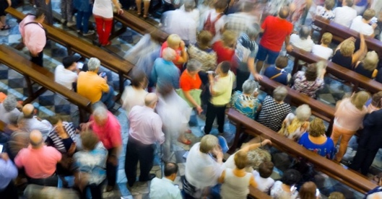Photo Courtesy: Thinkstock

**Consider Paul's language ("In the Church" v. "Outside the Church"):**

Or consider 1 Corinthians 5:12-13 – **“What have I to do with judging outsiders? Is it not those inside the church whom you are to judge? God judges those outside. ‘Purge the evil person from among you’” (1 Cor. 5:12-13).**

It is clear from Paul’s language that there is an “in the church” group and an “outside the church” group. Being in the church is definable. There are recognizable boundaries that make drawing this distinction possible. The objective criteria that constitute those boundaries would be the terms of membership in the church. It is also clear that a person can be removed from being “in the church.” Such a formal removal would not be possible if there were no such thing as a clear membership. In other words, Paul’s exhortation would be impossible to obey unless there were a way of determining who is an accountable part of a local body and who is not. Simply put, formal exclusion presupposes formal inclusion.

**Michael McKinley provides this helpful illustration:**

“I cannot be removed from the Northern California Left Handed Golfer’s Association because I have never been a member of such an organization. Now according to their website, the NCLHGA will remove people from membership for several reasons (like right-handedness, perhaps?). But I am in no danger of being subject to such an action, because you can’t kick a person out who was never a member to begin with.”

The church’s discipline is to occur when "you are assembled" ([1 Cor. 5:4](https://biblia.com/bible/esv/1%20Cor.%205.4)). For our purposes, simply note that there was a definite and formal assembly of the church, and they knew who to expect when it gathered. The church would have to have known who constituted its membership.

Apart from some expression of formal membership, how would it be determined who has the right to speak and to vote in the passing of judgment on the offending party? Surely this right would not extend to just anyone. Otherwise the person being disciplined could bring in extended family members and friends or coworkers or even people off the street who said they believed in Jesus. What about the person who has attended services only at [Christmas](https://www.crosswalk.com/special-coverage/christmas-and-advent/what-is-christmas-understanding-the-history-and-origin.html) or [Easter](https://www.crosswalk.com/faith/spiritual-life/undertanding-the-history-and-symbols-of-easter-1256039.html), or perhaps someone who hasn’t been present for several years but occasionally sends in a support check? The right to engage in the disciplinary process must be limited to a specific group, one that is limited by the criteria that constitute membership in the body.

Photo Courtesy: Thinkstock

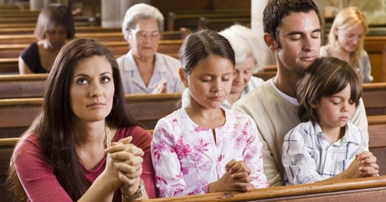**Those Inside the Church**

The “discipline” of which Paul speaks was intended only for those who are in the church (v. 12). Evidently some in Corinth were avoiding contact with immoral unbelievers outside the church. Paul seeks to correct this misunderstanding by reminding them that the church’s judgment was aimed only at those “inside” the church. It seems clear that **the church knew who was an insider and who was an outsider**. Those “inside” the church must have been united to one another or committed in some special way beyond just casual acquaintance.

One author sums it up this way: “You can't fire someone who doesn't work for you. You can't vote in your country to remove a government official elected by another country. You can't appeal to a court to discipline someone who isn't within its jurisdiction. In the same way, you can't formally discipline someone who is in an informal relationship with you; you have no authority to do so. These people in Corinth had voluntarily committed themselves to a formal relationship and they knew who were official members of the church and who were ‘outside’.”

**In**[**2 Corinthians 2:6**](https://biblia.com/bible/esv/2%20Cor%202.6)**, Paul refers to the discipline the church inflicted on an individual as the “punishment by the majority.”** The existence of a “majority” only makes sense if there was a defined set of people from which the majority is constituted. There cannot be a majority of an unspecified group; it must be a majority of **something**. This brings us back to the point made earlier in conjunction with the disciplinary process in [1 Corinthians 5](http://www.biblestudytools.com/search/?t=niv&q=1co+5). Was it the majority of people who happened to be present the day the vote was cast? Could non-Christians then vote? Could any Christians who happened to be visiting from another city who didn’t know the situation vote? The most natural assumption to make is that Paul meant the majority of an acknowledged membership of the church.

Photo Courtesy: Thinkstock

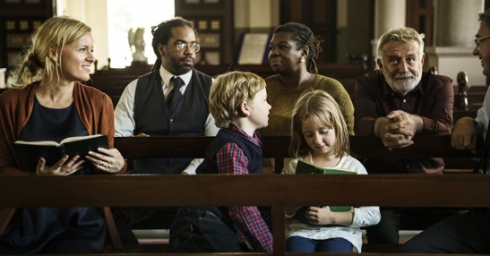

**(Slide #33)**

**7. It's likely certain criteria or standards were in place in the Early Church (to set apart believers authorized to join in decision-making)**

In Acts 15:22 we read the following: **“Then it seemed good to the apostles and the elders, with the whole church, to choose men from among them and send them to Antioch with Paul and Barnabas” (Acts 15:22).**

A decision needed to be made concerning those who would be entrusted with a letter summing up the conclusions of the Jerusalem Council.

The decision was made not only by the apostles and the elders but in conjunction with “the whole church.” Who constituted the “whole church”? How was it known that one either was or was not part of the “church” in Jerusalem? How was it determined who had a right to speak into this matter? Would anyone who happened to be present at the meeting be given a voice?

I find it highly unlikely that any person, regardless of belief, behavior, or involvement in the life of the body could simply assert himself into this affair. It is difficult to escape the conclusion that certain criteria or standards were in place that served to set apart those believers who were authorized to join with the apostles and elders in making this decision.

Photo Courtesy: Thinkstock

**(Slide #34)**

**8. Consider Paul's mention of "the household of faith."**

**Consider Paul’s exhortation in Galatians 6:10 – “So then, as we have opportunity, let us do good to everyone, and especially to those who are of the household of faith.”**

**As Christians, we are responsible to display the love of Christ to “everyone,”** i.e., to all people regardless of their spiritual convictions. **But we have a unique responsibility “to those who are of the household of faith.”** The local church is here portrayed as a family, spiritual “brothers” and “sisters” whose presence in the house and identity as members of that family are obvious.

We don’t know what the criteria were that identified one as a family member and thus the object of this particular display of “good,” but there had to have been some means by which the household of faith was differentiated from “everyone” else. This is what is meant by “covenant membership” in the family of God’s children.

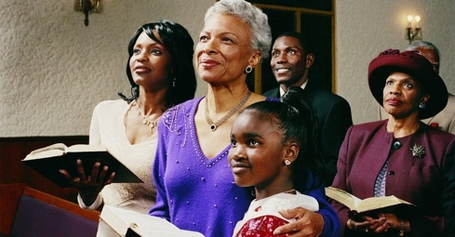Photo Courtesy: Thinkstock

**(Slide #35)**

**9. There were times in the New Testament "the whole church [came] together."**

**In 1 Corinthians 14:23, Paul describes a situation in which “the whole church comes together.” How would the leaders know if the “whole church” was there if no formal covenant relationship was established?** The fact that Paul envisioned a group that could be identified and defined as everyone who belonged to that local body necessarily assumes that some means or mechanism had to be in place by which such people could be known. I think that means or mechanism or whatever other word you find appropriate is what I am calling “covenant membership.”

Photo Courtesy: Thinkstock

**(Slide #36)**

**10. The Church is described as "Body", "Flock", and "Building."**

**Covenant membership is implied in the metaphor of the “body” in 1 Corinthians 12:12-13.** The original meaning of the word “member” is member of a body, like hand and foot and eye and ear. **That’s the imagery behind the word “member”** in the text (vv. 12, 14, 18, 19, 20, 23, 25, 26, 27). **Verse 12: “Just as the body is one and has many members, and all the members of the body, though many, are one body, so it is with Christ.”**

So the question this imagery raises for the local church that Paul is describing in 1 Corinthians 12is: **Who intends to be treated as a hand or foot or eye or ear of this body?** There is a unity and organic relationship implied in the imagery of the body. There is something unnatural about a Christian attaching himself to a body of believers and not being a member of the body. **Neither Paul nor any other biblical author ever describes a Christian as one who functions or exists in isolation from the whole.**

In addition to the metaphor of the **“body”** (1 Corinthians 12:12-13) the New Testament speaks of the church as a **“flock”** (Acts 20:28) and a **“building”** (1 Peter 2:5). **In each of these metaphors, there is an obvious relationship between the individual and the congregation as a whole.** The individual Christian is a member of the body and a sheep in the flock. The individual believer is, in Peter’s words, "a living stone" in the spiritual house.

Each of these word pictures, so vital to our understanding of the church, demand more than a casual commitment from the individual. There are no informally connected stones in a building. They are cemented together unambiguously. Sheep do not hop from flock to flock; rather, the shepherd knows exactly how many sheep he has in his care. Body parts do not relate to each other informally; they are intricately connected to each other and are mutually dependent. **Surely, we best reflect these metaphors when we formally tie ourselves to a local congregation.**

Photo Courtesy: Thinkstock

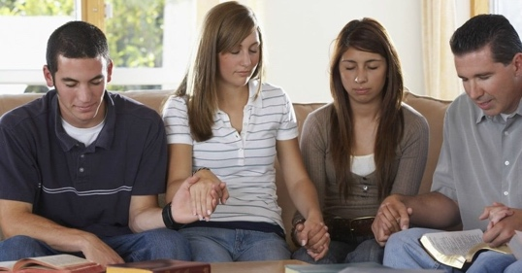

**(Slide #37)**

**Conclusion: Why Covenant With The Church Family Fellowship in Membership Adoption?**

So, why covenant membership? It isn’t because we want to be like some other church, or even because we want to be unlike someone else. **It is because we want to be biblical.**

**It is because this world wants to sell you a bill of goods and to shape you in its image.** The world wants to convince you that:

* You should maintain your independence and autonomy.  
  Spiritual authority, or any kind of authority for that matter, is evil.  
  You should float around, but never settle down.  
  And if you don’t like what is being offered in your church, there are at least a dozen more down the road that will surely have what you’re looking for.

Why be adopted into The Church covenant membership? So that **when your life starts to fall apart** (however or whenever that may happen) you can rest assured that **others** who have pledged and promised themselves to you **will be there, to love and support you, to pray for you, to instruct you, to walk with you through the worst of times**.

Why be adopted into The Church covenant membership? So that in the face of rampant relativism and postmodern mush that says truth is whatever each individual wants it to be **you can stand arm-in-arm with brothers and sisters in Christ and say: “This, the Word of God, is truth. We are united by covenant in our commitment to what it says**. And we’re willing to go to the ends of the earth together to make it known, and if necessary to die for it."

**(Slide #38) So How Do I Become A Covenant Member of The Church Family Fellowship?** We call it our Discipleship/Adoption Process. **(Slide #39)**



**Part 1 You become identified as someone who would like to call TCFF your home-church (or you may have gone through the first video and answered the three questions and that was how you got identified too). You get assigned a Discipling Partner and have an initial meeting and you are emailed the video links to go through The Church Process videos. (Slide #40)**

**Part 2 You watch through the videos and after each one your Discipling Partner meets with you to go over any questions you have and ensures any forms or information you need is provided (like helping you get connected with next baptism opportunity or spiritual gifts inventory, or ministry) then encourages you to go on to the next video.**

**Once you have completed all the videos then they will connect you with one of the Elders to discuss if you would like to complete the Adoption process by having TFCC become your church home. If yes, then we will arrange for an opportunity to introduce you to The Church Family Fellowship (i.e., at a lunch after church or some other opportunity like that) and you will become Adopted into The Church Family Fellowship.**

**If you choose not to call TFCC your home, you are welcome to continue to be a friend of TFCC and join with us as you can, but we will always seek to encourage you to “find a place where you can belong!”**

***This article originally appeared on***[***SamStorms.com***](http://www.samstorms.com/enjoying-god-blog/post/10-things-you-should-know-about-church-membership)***. Used with permission.***

<https://www.youtube.com/watch?v=FjklGJeXh6E>

APRIL 12, 2023

The amount of scripture extolling believers to fellowship with one another is abundant: **Acts 2:42 “And they devoted themselves to the apostles teaching and the fellowship, to the breaking of bread and the prayers.”** **Hebrews 10:25 “Not neglecting to meet together as is the habit of some…”,** **Mathew 18:20 “Fore where two or three are gathered in my name, there am I among them.”** Just to name a few.

Being connected to a local church is a key way we practice fellowship. It’s not just that you need the church, but the church needs you as well. In this [Worship Sound Bite](https://worshipleader.com/tag/worshipsoundbites/), [Bart Millard](https://bartmillard.org/) tells how [Mercy Me](https://mercyme.org/) values each member staying connected with their local church, and what a difference that makes in their relationship with each other, and to their ministry.

**(Slide #41)**

**BART MILLARD ON NEEDING THE LOCAL CHURCH**

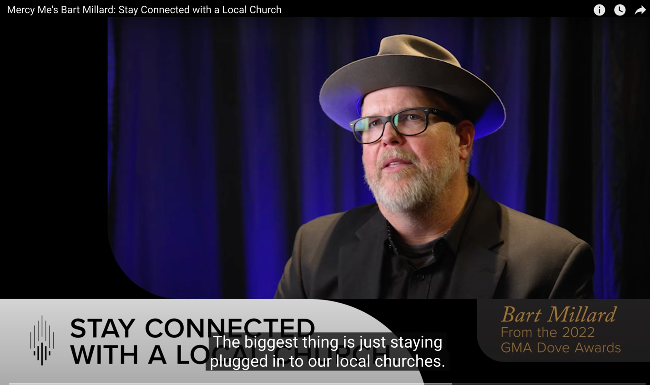

In a day and age where everyone can do church at home, in their pajamas, the concept of fellowship is being redefined to some degree. But should it? God made us to be social creatures, both introverts and extroverts. Each brings positives and negatives to the table that is the church.

The fellowship spoken of in **Acts 2:42 speaks of devotion to the apostles’ teaching, the breaking of bread together, and prayer.** **This (is)** gives us a sound framework to build **our definition of fellowship.**

**(Slide #42)**

**Hebrews 10:24-25** says, **“And let us consider how to stir up one another to love and good works, not neglecting to meet together, as is the habit of some, but encouraging one another, and all the more, as you see the Day drawing near.”**

**(Slide #43)** “Paul is admonishing us as believers to meet together so we can encourage each other to love one another, to do good works that glorify God, and to encourage one another personally. ~~In the Worship Sound Bite, Bart points out how the members of Mercy Me have that connection both outside the band and within the band. This facilitates the worship and ministry they engage in together.~~

I know there is no perfect church. After all, it’s composed of imperfect people serving imperfect people. That is why the local church needs you, and you need the local church.”

[CHRISTOPHER WATSON](https://worshipleader.com/author/christopher-watson/)

Christopher Watson is an author of six books, both fiction and non-fiction. He is also a musician and composer with a B.A. in Music from Azusa Pacific University. For several years Christopher led worship at The Springs Church while attending Dallas Theological Seminary in Dallas Texas. He's been involved with worship in a number of churches in California and the Pacific Northwest both as a musician and in production and technology. Now he lives and writes in Washington State with his amazing wife, wonderful daughters, and highly intelligent dog, Ellie Mae.

**(Slide #44)**

**The Definition of Church Membership** By John MacArthur

“When an individual is saved, he becomes a member of the body of Christ (1 Cor. 12:13). Because he is united to Christ and the other members of the body in this way, he is therefore qualified to become member of a local expression of that body.

To become a member of a church is to formally commit oneself to an identifiable, local body of believers who have joined together for specific, divinely ordained purposes. These purposes include receiving instruction from God’s Word (1 Tim. 4:13; 2 Tim. 4:2), serving and edifying one another through the proper use of spiritual gifts (Rom. 12:3-8; 1 Cor. 12:4-31; 1 Pet. 4:10-11), participating in the ordinances (Luke 22:19; Acts 2:38-42), and proclaiming the gospel to those who are lost (Matt. 28:18- 20). **In addition, when one becomes a member of a church, he submits himself to the care and the authority of the biblically qualified elders that God has placed in that assembly.” And choses in response to give of his or her time, talent, and treasure to the work that the Lord is doing through that local body of believers…**

**(Slide #45)**

“**12**to equip the saints for the work of ministry, to build up the body of Christ, **13**until we all reach unity in the faith and in the knowledge of God’s Son, growing into maturity with a stature measured by Christ’s fullness. **14**Then we will no longer be little children, tossed by the waves and blown around by every wind of teaching, by human cunning with cleverness in the techniques of deceit. **15**But speaking the truth in love, let us grow in every way into him who is the head—Christ. **16**From him the whole body, fitted and knit together by every supporting ligament, promotes the growth of the body for building itself up in love by the proper working of each individual part.”

**Ephesians 4:12-16**

**FINAL STATEMENTS:**

**If you are interested in becoming an Adopted Member of The Church Family Fellowship, all you need do is to have completed all six (6) of these sermon series and answer the 3, or so, questions at the end of each video which you can find on line through our website located at** [**www.thechurchhome.com**](http://www.thechurchhome.com)**. Upon completion of the first video, you should be contacted within that same week by one of our leadership team, who will disciple you throughout the rest of the sermon series, ensuring you have all your questions answered regarding The Church’s foundational teachings. Additionally, they will assist you in getting plugged into the fellowship and walk with you through the remainder of the ministry steps until you have concluded the six (6) sermon series and notify them that you would like to call The Church Family Fellowship your home church. At that point you will meet with one of our Church Elders to welcome you into The Church Family and together you will identify the best Sunday opportunity in which we can welcome as an Adoptee to The Church Family Fellowship (i.e., on a Sunday at one of our fellowship lunch gatherings, etc.).**

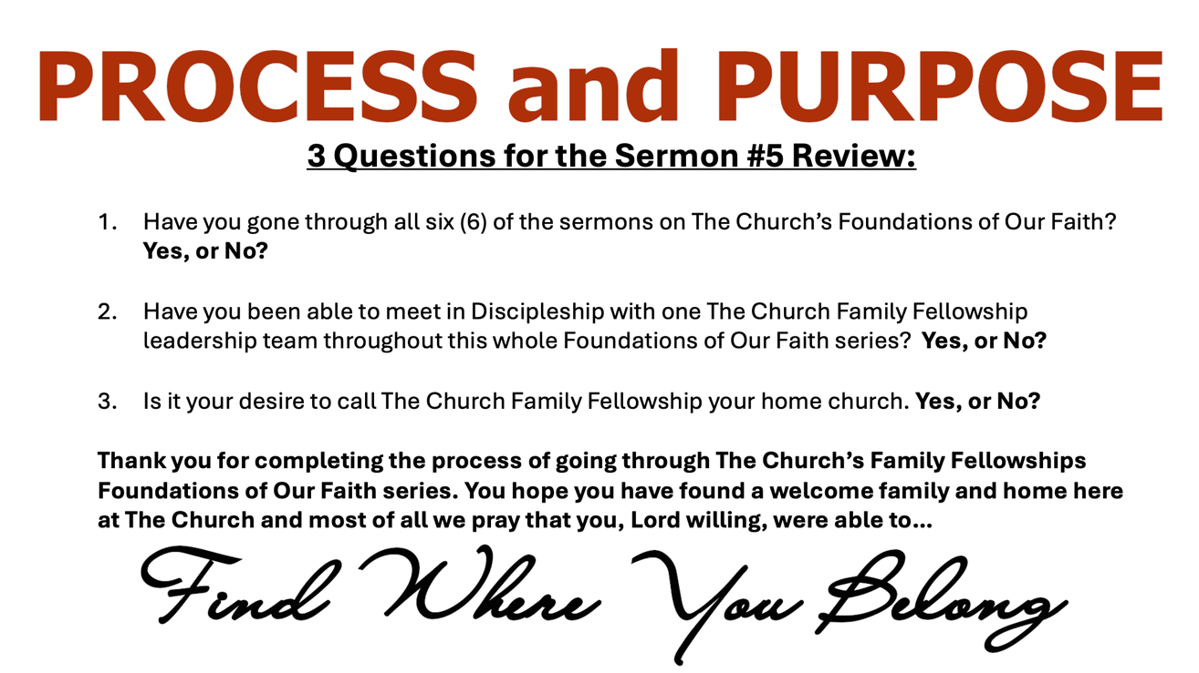

**(Slide #46)**

